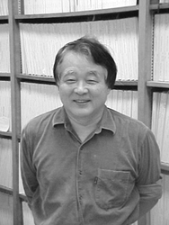
Dr. Takeshi Oka
Professor, Department of Chemistry, and Department of Astronomy and Astrophysics, The University of Chicago, U.S.A.
Staying Period: December 19, 2003 - December 23, 2003

Host: Takamasa Momose (Div. Chem., Grad. Sch. Sci.)

Professor Takeshi Oka is a well-known high-resolution spectroscopist all over the world. He is especially famous for his discovery and identification of H₃⁺, which has been known to be a key molecule in interstellar chemistry. Based upon the infrared spectrum of H₃⁺ observed in his laboratory, he is now actively search for H₃⁺ in various interstellar space to get insight into the origin of molecules in the space. He has established a new research field which is now called "astro-chemistry". He is also known as a pioneer of high-resolution spectroscopy in solid parahydrogen.
During his stay, he discussed with students in Momose's lab. at the Department of Chemistry, Graduate School of Science about interstellar chemistry as well as high-resolution spectroscopy of molecules in solid parahydrogen. Especially we have discussed on the importance of the conservation of nuclear spin states in chemical reactions. Abundance ratio of different nuclear spin states may give us useful information on how a molecule produced in the space. Momose's lab. is now working on the observation of abundance ratio of different nuclear spin states of cyclic-C₃H₂ in several molecular clouds. The discussion was very fruitful for both of us.
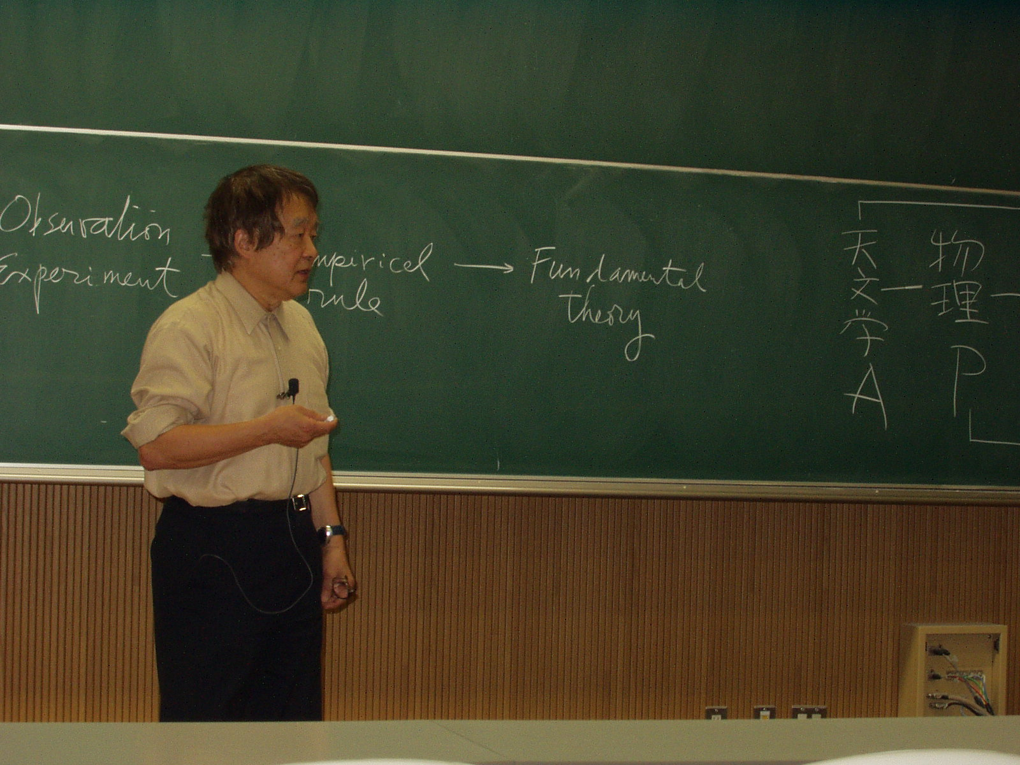
He gave two lectures during his stay in Kyoto University. The first lecture was about "Astronomy and Chemistry" which was held on November 19th (Wednesday), 2003. This lecture was an introduction of astro-chemistry and mainly for freshman students of Kyoto University. More than 80 people, most of them were 1st and 2nd year students, were attended to this lecture. The second lecture was held on November 21st (Friday), 2003. The title of the lecture was " H₃⁺ and other protonated ions in the universe". This lecture was for advanced students in both chemistry and astronomy. More than 40 students and faculty members were attended. In both lectures he gave us very good introduction of astro-chemistry with enthusiasm. It is certain that astro-chemistry is a new research field which combines both chemistry and astronomy.

