(Dr.) Laszlo Nagy
Associate Professor in Szeged University
Department of Biophysics, Szeged, H-6722, Hungary
staying period: July 16, 2002 - July 22, 2003

Host: M.Terazima (Div.Chem., Grad.Sch.Sci.)

Dr. Nagy is a well established bio-physicist in Hungary working on the photosynthesis reaction center. During his stay in our laboratory, Dr. Nagy performed two tasks.
One is a cooperative research on the kinetic measurement of protein conformation change of reaction center (RC) protein associated with the charge separation process. There is no doubt that studying the photosynthetic conversion of light into chemical energy is extremely important in many points of view (Fig.1). The RC purified from purple bacteria provides an extremely unique system for studying the requirements for high efficiency conversion of light into electrochemical energy. The aim of the research in the short term period is to set conditions for carrying out thermal optical measurements with photosynthetic reaction centers purified from purple bacteria. The duration of the visit covers basic laboratory measurements with the thermal grating technique on isolated RCs and discussions about possible future collaboration. There are many questions which can be addressed and expected to be answered by using this technique. The main problems among others: 1) To identify the structural and heat release components accompanied the subsequent electron transport steps after light excition (Fig.2). 2) What is the role of carotenoid in energy utilization of the RCs. 3) To measure the heat attenuation, kinetics and mechanism, within the protein. The following biological materials were used: 1) RCs from the carotenoidless Rhodobacter (Rb.) sphaeroides R-26 purple bacteria; 2) RCs from the wild type, i.e. carotenoid containing Rb. sphaeroides 2.4.1 strain;
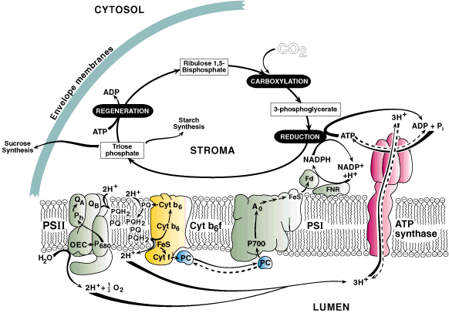
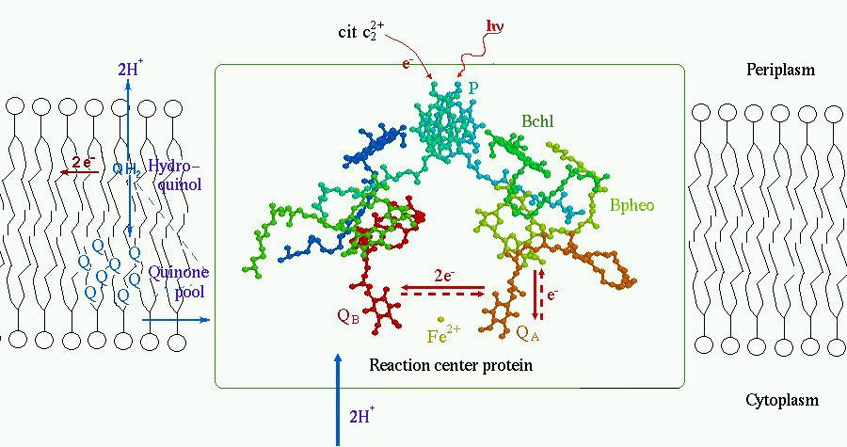
The second task was the instructive lecture entitled as 'From photons to protons in photosynthetic energy conversion'. This lecture was aimed mostly to educate undergraduate and graduate students, who are interested in biological science from a view point of chemistry. He gave us a nice lecture from the detail introduction of photosynthesis to the recent advanced researches, such as addressing how and why the photon energy can be converted into the chemical energy.
Fig.1 (left) Scheme of energy creation process using a photosynthesis reaction center
Fig.2 (right) Schematic showing the electron transfer process in RC.

